User manual
Table of contents
How to login
- Website is displayed on browser
- Go to menu CMS



Insert your user name and insert your password
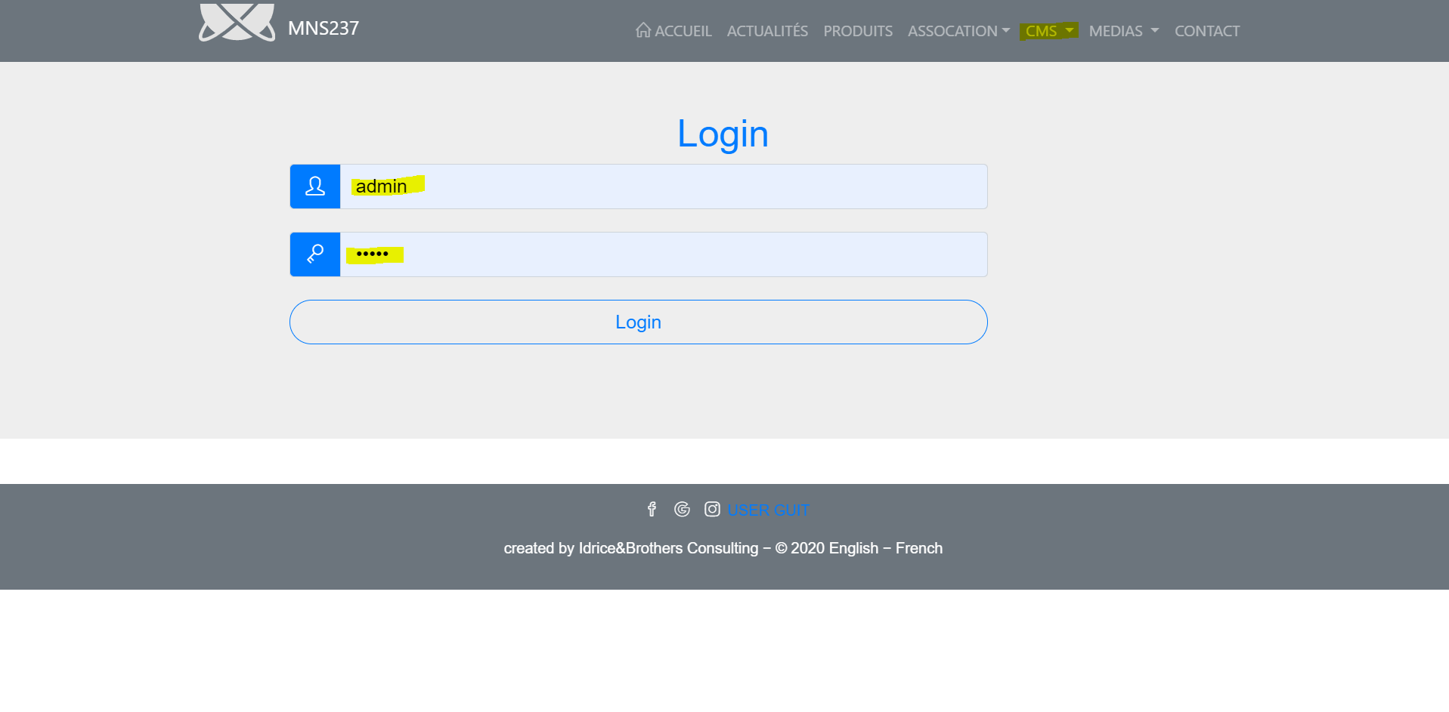
The Platform should dispay the page with your username.
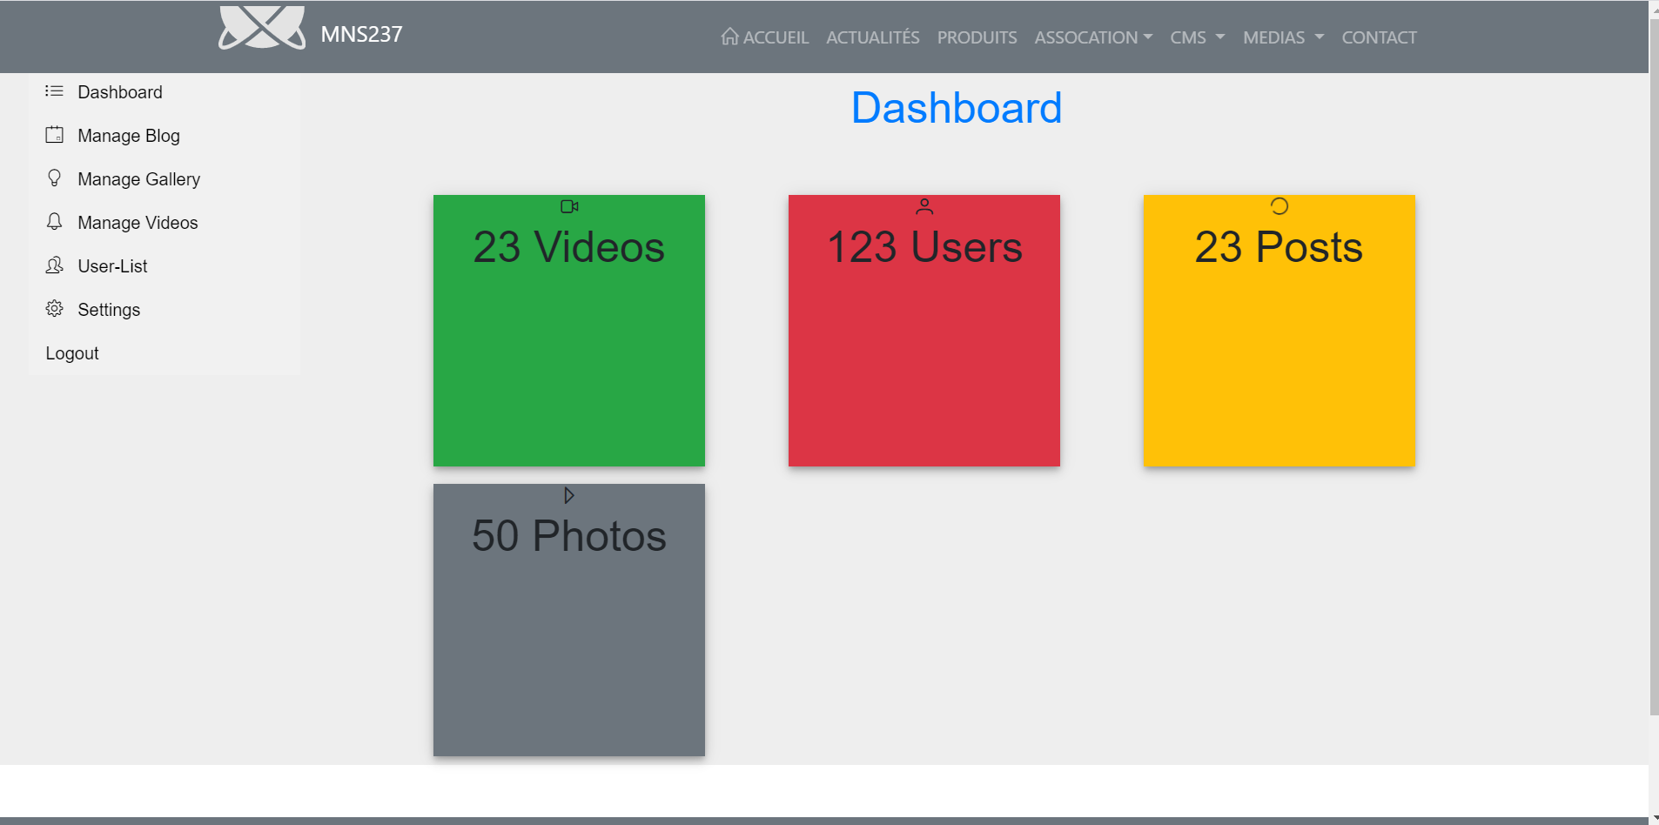

How to send contact
- Website is displayed on browser
- Go to menu Contact
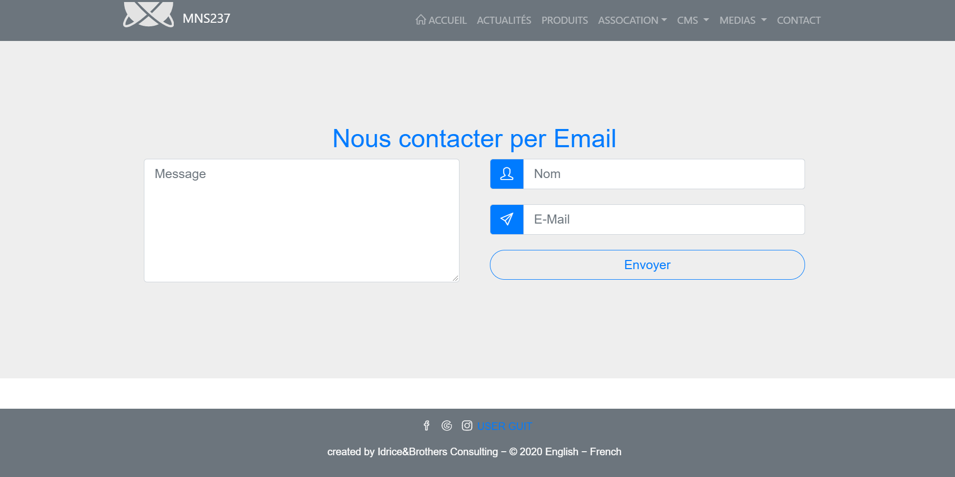
Insert your user name
1. Insert your email
1. Dial your message
1. Press ' Send'
1. The Platform should send your message successfully.

